The Centre for Ageing Better has recently produced a report on the views held by society on ageing based upon the language people use to describe older people and later life.
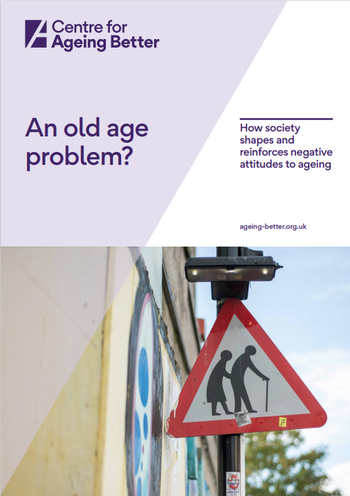
The report analyses the language used across society including in
In summary, it has found:
- Ageing is seen as a negative issue
- Ageing is recognised by psychical and mental decline
- Ageing is synonymous with ill health
- Ageing is seen as a fixed destination (becoming old), not as a life long process
- Attitudes to ageing and attitudes to older people have become the same thing
- People in later life have become characterised as frail, vulnerable and dependent
- People in society are living longer; this means more frail, vulnerable and dependent people – we are a growing burden
- People in later life are portrayed as the source of conflict between the different generations
- Advertisers who promote both Active and Anti Ageing are reinforcing the stereotypes of older people

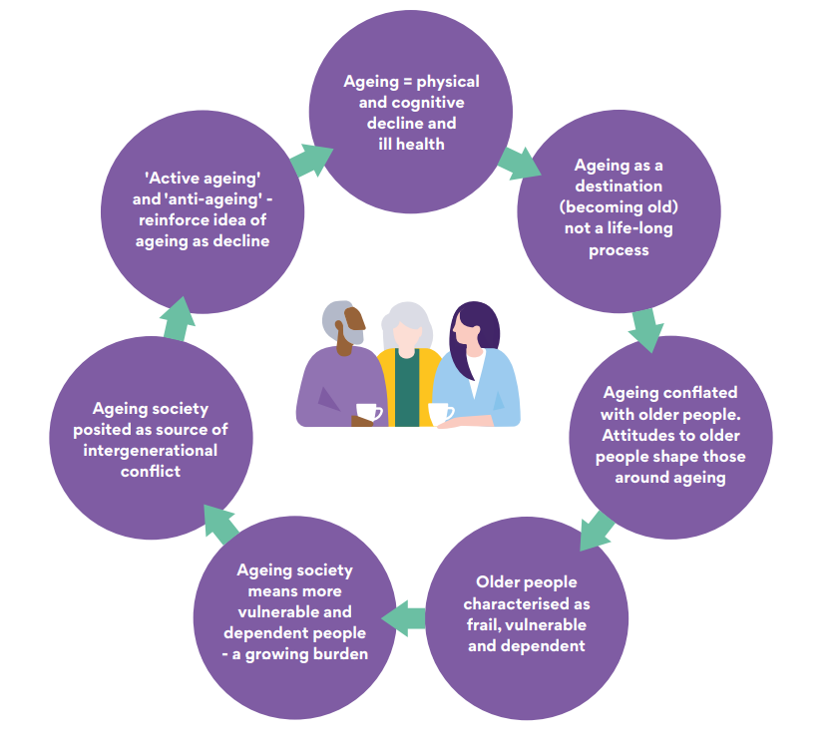

The tables below show the top 10 most common words/phrases used by people within different groups in society when discussing people in later life or ageing:

The top ten most common words used overall by all sectors of society
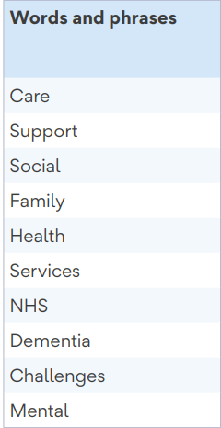

Most common words used by the Government Sector when discussing people later in life

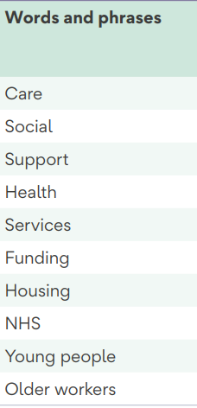

Words and phrases most likely to appear in online news articles related to ageing

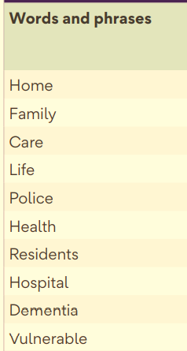

Words and phrases most likely to appear in social media posts about ageing

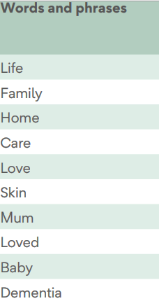

Descriptive words used most in describing ‘old’ in social media

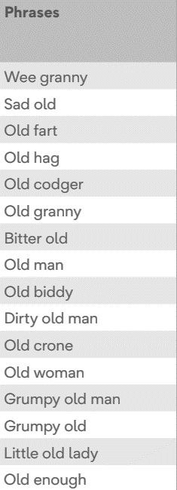

Top 10 words and phrases most likely to be used in TV advertisements

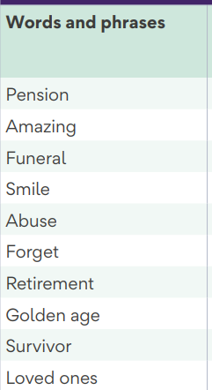

Top 10 words and phrases most likely to appear in charity sector discourse about ageing

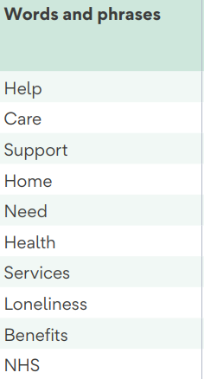

In conclusion

The research in this report indicates that people in later life are thought of as negative stereotypes by people in other groups in society. Many people judge them to be frail, dependent, physically and mentally less competent than younger people, yet also having greater political power and accumulated wealth. There is also a trend towards anger from different generations towards older people as they see them as having an unfair share of public resources and a burden on society. The report suggests this image is reinforced by the language used in connection with people in later life and is pervasive throughout society.

Read the full report by clicking on the picture below

